Lab 03 Propositional Equivalences
Objective
Solving exercises from the textbook in chapter 1.3

Current Lab Learning Outcomes (LLO)
By completion of the lab, the students should be able to:

- Understand propositional equivalences and .
- prove the propositional equivalences using rules

Lab Requirements
Students allowed using their lecture notes in the lab in order to solve the exercises.

Lab Assessment
1- Divide students to groups and let them to solve the given example.
2- Discuss the answers with the groups and write on board the optimal solution.
Lab Description

- Show that ￢(p ∨ ￢(p ∧ q)) is contradiction using rules.
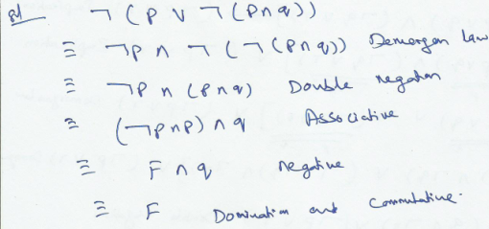

- show that [(p ∨ q) ∧ (p → r) ∧ (q → r)] → r is a tautology using rules

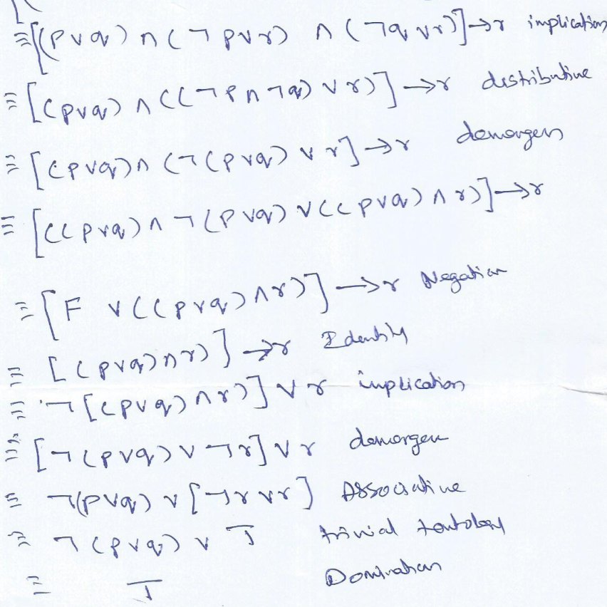

- Show that [p ^ (p → q)] → q is a tautology using rules
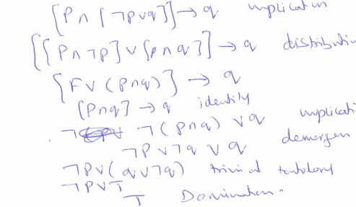
- Show that [¬p ∧ (p ∨ q)] → q is a tautology using rules.

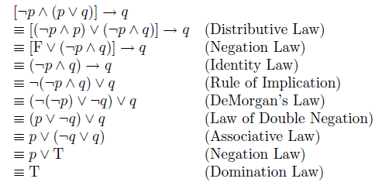
- Show that ¬ p→ (q → r) and q →( p v r) are logically equivalent using rules.
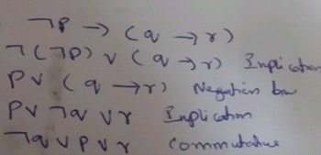

- Show that ¬p ↔ q and p ↔ ¬q are logically equivalent using rules
¬p ↔ q ⇔ (¬p→q) ∧ (q→¬p) Biconditional
= (¬¬p∨q) ∧ (¬q∨¬p) Implication
= (p∨q) ∧ (¬q∨¬p) Double Negation
= (q∨p) ∧ (¬p∨¬q) Commutative
= (¬¬q∨p) ∧ (¬p∨¬q) Double Negation
= (¬q→p) ∧ (p→¬q) Implication
= p ↔ ¬q Biconditional

- Determine whether¬(p∨(¬p∧q)) and (¬p ∧ ¬q) equivalent using rules?
¬(p∨(¬p∧q)) =¬p ∧ ¬(¬p∧q) DeMorgan
=¬p ∧ (¬¬p∨¬q) DeMorgan
=¬p ∧ (p∨¬q) Double Negation
=(¬p∧p)∨(¬p ∧¬q) Distribution
=(p∧¬p)∨(¬p ∧¬q) Commutative
=F ∨(¬p ∧¬q) Negation
= (¬p ∧¬q) ∨ F Commutative
= (¬p ∧¬q) Identity
¬(p∨(¬p∧q)) and (¬p ∧ ¬q) equivalent

Exercises:
- (p → r) v (q → r) is equivalent to (p ^ q) → r
- P ↔ q is equivalent to ¬p ↔ ¬q

